SMART CARE

SUBMITTED IN PARTIAL FULFILLMENT FOR THE REQUIREMENT OF THE AWARD OF DEGREE OF

BACHELOR OF TECHNOLOGY
IN
COMPUTER SCIENCE



Submitted by

Hanu Agarwal (2000290120067-A)
Chhayank Tyagi (2000290120059-A)
KHUSHI(2100290129005)

Supervised by

HARSH KHATTER

Session 2023-24

DEPARTMENT OF COMPUTER SCIENCE
KIET GROUP OF INSTITUTIONS, GHAZIABAD
(Affiliated to Dr. A. P. J. Abdul Kalam Technical University, Lucknow, U.P., India)
DECLARATION
I/We hereby declare that this submission is our own work and that, to the best of our knowledge and belief, it contains no material previously published or written by another person nor material which to a substantial extent has been accepted for the award of any other degree or diploma of the university or other institute of higher learning, except where due acknowledgment has been made in the text.

Signature
Name:- Chhayank Tyagi
Hanu Agarwal
Khushi
Roll No.:- 2000290120059
2000290120067
2100290129005
Date:- 12/03/2024

CERTIFICATE

This is to certify that Project Report entitled “ SMART CARE ” which is submitted by Chhayank Tyagi, Hanu Agarwal, Khushi in partial fulfillment of the requirement for the award of degree B. Tech. in Department of Computer Science of Dr. A.P.J. Abdul Kalam Technical University, Lucknow is a record of the candidates own work carried out by them under my supervision. The matter embodied in this report is original and has not been submitted for the award of any other degree.
.

Date: 12/03/2024 Supervisor
Mr. Harsh Khatter
(Associate Professor)

ACKNOWLEDGEMENT

It gives us a great sense of pleasure to present the report of the B. Tech Project undertaken during B. Tech. Final Year. We owe special debt of gratitude to Professor Mr. Harsh Khatter (Associate Professor), Department of Computer Science, KIET, Ghaziabad, for his/her constant support and guidance throughout the course of our work. His/Her sincerity, thoroughness and perseverance have been a constant source of inspiration for us. It is only his cognizant efforts that our endeavors have seen light of the day.
We also take the opportunity to acknowledge the contribution of Dr. , Head of the Department of Computer Science, KIET, Ghaziabad, for his full support and assistance during the development of the project. We also do not like to miss the opportunity to acknowledge the contribution of all the faculty members of the department for their kind assistance and cooperation during the development of our project.
Last but not the least, we acknowledge our friends for their contribution in the completion of the project.
Date : 12/03/2024
Signature:
Name : Chhayank Tyagi
Hanu Agarwal
Khushi

Roll No: 2000290120059
2000290120067
2100290129005

ABSTRACT

Mobile Ad hoc network is network where nodes communicate without any central administration or network infrastructure. They are connected via wireless channels and can use multiple hops to exchange data. Routing protocols are needed for communication in such Ad hoc networks, where it targets for efficient and timely delivery of message. There are various performance metrics to compare Ad hoc routing protocols. It also provides a step by step approach based on assumption on how to carry out such a comparative study, which could be used for future research. The cardinal concept of TCP development was to carry data within the network where network congestion plays a vital role to cause packet loss. On the other hand, there are several other reasons to lose packets in Mobile Ad Hoc Networks due to fading, interfaces, multi-path routing, malicious node and black hole. Along with throughput, fairness of TCP protocols is important to establish a good communication. The simulation work has been done in NS2 environment on platform Linux (Ubuntu) using X-graph, trace graph and Nam file. Based on the simulation results we carried out observations for different TCP packets under several QoS metrics in AODV and DSDV on Drop, Packet Delivery Fraction , End to end delay and Normalized Routing load while varying the number of nodes, speed, Pause time, throughput, delay, and jitter. After simulating on these parameters we have come to conclusion that AODV (Ad-hoc On-Demand Distance vector) performs better than DSDV (Destination Sequence Distance Vector). In future we would work on traffic congestion and other similar parameters with other protocols as well.

TABLE OF CONTENTS | Page No.
DECLARATION……………………………………………………………………. | ii
CERTIFICATE……………………………………………………………………… | iii
ACKNOWLEDGEMENTS…………………………………………………………. | iv
ABSTRACT………………………………………………………………………..... | v
LIST OF FIGURES…………………………………………………………………. | ix
LIST OF TABLES…………………………………………………………………… | xi
LIST OF ABBREVIATIONS………………………………………………………. | xii
CHAPTER 1 INTRODUCTION PAGE NO.
1.1 INTRODUCTION TO PROJECT
1.2 PROJECT CATEGORY(INTERNET BASED, APPLICATION OR SYSTEM DEVELOPMENT, RESEARCH BASED ,INDUSTRY AUTOMATION, NETWORK OR SYSTEM ADMINISTRATION)
1.3 OBJECTIVES
1.4 PROBLEM FORMULATION
1.5 PROPOSED SYSTEM
1.6 UNIQUE FEATURES OF THE SYSTEM

CHAPTER 2. REQUIREMENT ANALYSIS AND SYSTEM SPECIFICATION
2.1 FEASIBILITY STUDY (TECHNICAL, ECONOMICAL, OPERATIONAL)
2.2 SOFTWARE REQUIREMENT SPECIFICATION DOCUMENT WHICH MUST INCLUDE THE FOLLOWING:
(DATA REQUIREMENT, FUNCTIONAL REQUIREMENT, PERFORMANCE REQUIREMENT
, MAINTAINABILITY REQUIREMENT, SECURITY REQUIREMENT)
2.3 SDLC MODEL TO BE USED

CHAPTER 3. SYSTEM DESIGN
3.1 DETAIL DESIGN
3.2 SYSTEM DESIGN USING DFD LEVEL 0 AND LEVEL 1
3.3 USE CASE DIAGRAM
3.4 DATABASE DESIGN
3.4.1 ER DIAGRAMS

CHAPTER 4. IMPLEMENTATION, TESTING, AND MAINTENANCE
4.1 INTRODUCTION TO LANGUAGES,TOOLS AND TECHNOLOGIES USED FOR IMPLEMENTATION
4.2 TESTING TECHNIQUES AND TEST CASES USED

CHAPTER 5. RESULTS AND DISCUSSIONS
5.1 USER INTERFACE REPRESENTATION (OF RESPECTIVE PROJECT)
5.1.1 BRIEF DESCRIPTION OF VARIOUS MODULES OF THE SYSTEM
5.2 SNAPSHOTS OF SYSTEM WITH BRIEF DETAIL OF EACH
5.3 BACK ENDS REPRESENTATION (DATABASE TO BE USED )
5.3.1 SNAPSHOTS OF DATABASE TABLES WITH BRIEF DESCRIPTION
CHAPTER 6. CONCLUSION AND FUTURE SCOPE

REFERENCES( REFERENCES SHOULD BE IN IEEE STANDARD)

LIST OF FIGURES

Figure No. | Description | Page No.
3.1 | Flowchart | 2
3.2 | DFD Level 0 | 9
3.3 | DFD Level 1 | 12
3.4 | Use Case Diagram of Smart Care
3.5 | Database Diagram of Smart Care
3.6 | ER Diagram of Smart Care

CHAPTER-1
INTRODUCTION

  - INTRODUCTION TO PROJECT
The Smart Healthcare website which aims to solve many problem of patients and doctors i.e it provides the facility of saving the medical reports online. Sometimes when patients changes their doctors, then some of patients lost their prescriptions and are unable to tell doctors about their previous health issues so they can save all of their reports and documents on the platform for their better cure. The platform is also helpful for doctor as doctor can save all their patients history in efficient manner. Doctors can also refer prescriptions of other doctor for betterment.

  - OBJECTIVES

- To Combine technology and digital tools to improve Health care system and make it Smart i.e. SMART CARE
- Increase the efficiency of healthcare delivery and treatment by the doctors
- Patients can have their documents in well-structured form.
- Doctor can also maintain the records of their patients and can see their reports and prescription through the patient id generated by software if patients want to show.

  - PROBLEM FORMULATION

- Many of the hospital have healthcare solutions for the document and patient record purposes.
- But Patient don’t have the access to see all the details and medical history.
- There are various common cases for patients like:
  - Patients generally refer multiple doctors and clinics for the treatment of the disease
  - Some of the times, patient face challenges in maintaining reports of tests and doctor prescription i.e. paper-based health records and their prescriptions.
  - Patients are unable to tell the exact health issues and what had happened previously, where the doctor need to know about the previous treatments and what is the history of the patient. This helps the doctor to take references from it and give the much effective treatment.

  - PROPOSED SYSTEM

The Smart Care- Health based web-app has a wide scope in the upcoming world as smart health have gained significant attention in recent years as an innovative approach to healthcare. This system helps medical professionals in making accurate and timely diagnoses, as well as provide the correct treatment based on patient data. Connecting patients and doctors through a user-friendly interface will make it easier for patients to use in emergency situations. Integrating many platforms under one roof, such that blood availability, medicine availability, path-Labs services and also provide the storage of documents.
We can monitor patients in real-time, predict potential health problems before they become big issues, and create personalized treatment plans that fit each person's unique needs. With "smart care," healthcare groups want not only to make medical treatments more efficient and effective but also to make healthcare services available to more people.
In healthcare, there's a constant effort to find new and better ways to meet the changing needs of patients and healthcare providers. These technologies help doctors and healthcare workers understand more about patients' health, make decisions faster, and create a healthcare system that really focuses on what each patient needs. As "smart care" progresses, it shows how committed healthcare groups are to using innovation and technology to make healthcare better, moving into a new time of improved patient care and medical success.

  - UNIQUE FEATURES OF THE SYSTEM

- Improved Accuracy –
Smart Health can provide more accurate results of services like generic medicines, E-Pharmacy than traditional risk assessment methods. This is because large amount of patient is going to visit our website which are already confused in buying the medicines among which website, so that they will be satisfied in terms of cost.
- Early Services –
Smart Health can help to provide the free services like Blood Bank, Lab Test, E-Pharmacy without any login or registration to the website. This improves the users accessing rate to our Smart Healthcare website.
- Personalized Generic Medicines –
Smart Health can provide personalized recommendations for buying the medicines from correct platform in terms of cost estimation. This can improve the individual risk factors which were affecting them like overall cost of medicines, their manufacturing dates and expiry dates.
- Providing the correct treatment –
Smart Health registered patients can get the better and correct treatment for their diseases. The prescriptions are provided by the doctor to the patient virtually. This is advantageous, as there is no loss of documents will be occurred.
- Providing Virtual Storage –
Smart Health is providing the storage for patient to store their medical history all together at one place. This will be advantageous, as it reduces the need of documents in hand. All the prescriptions are saved and secure from other non authorized users also.

CHAPTER 2
REQUIREMENT ANALYSIS AND SYSTEM SPECIFICATION

2.1 FEASIBILITY STUDY (TECHNICAL, ECONOMICAL, OPERATIONAL)

- Techinical feasibility
A study of resource availability that may affect the ability to achieve an acceptable system. This evaluation determines whether the technology needed for the proposed system is available or not.

- Can the work for the project be done with current equipment existing software technology & available personal?
- Can the system be upgraded if developed?
- If new technology is needed then what can be developed?This is concerned with specifying equipment and software that will successfully satisfy the user requirement.

- Economic feasibility
Economic justification is generally the “Bottom Line” consideration for most systems. Economic justification includes a broad range of concerns that includes cost benefit analysis. In this we weight the cost and the benefits associated with the candidate system and if it suits the basic purpose of the organization i.e. profit making, the project is making to the analysis and design phase. The financial and the economic questions during the preliminary investigation are verified to estimate the following:

- The cost to conduct a full system investigation
- The cost of hardware and software for the class of application being considered.
- The benefits in the form of reduced cost.
- The proposed system will give the minute information, as a result the performance is improved which in turn may be expected to provide increased profits.
- This feasibility checks whether the system can be developed with the available funds. The
- Smart Care does not require enormous amount of money to be developed. This can be done economically if planned judicially, so itis economically feasible. The cost of project depends upon the number of man-hours required

- Operational feasibility
It is mainly related to human organizations and political aspects. The points to be considered are:
- What changes will be brought with the system?
- What organization structures are disturbed?
- What new skills will be required? Do the existing staff members have these skills? If not, can they be trained in due course of time? The system is operationally feasible as it very easy for the End users to operate it. It only needs basic information about Windows platform.

2.2 SOFTWARE REQUIREMENT SPECIFICATION DOCUMENT WHICH MUST INCLUDE THE FOLLOWING:

- Functional Requirements –
The features of Smart Care web based project is -
Access the website - the access of our website is not restricted to registered users only. Someone who is not registered can also see the basic functionalities what the website is serving for.
Constantly update and modifying government’s health policy - The website will provide the service to access other official government websites. So that users of the website will be up-to-date, in respect to the policies which are mentioned on government website.
User Registration and login - A user, must be able to register their credentials. They should provide their basic functionalities about themselves eg. Name, address, email, phone number. They should also identify themselves the kind of users , that can be patient or doctor.
Electronic Health Records - This is a digital version of a patient’s medical records allow to access and update patient records in real-time, facilitating collaboration between the doctors and the patients.
Telemedicine - This feature allows the patient to buy the medicine online form the registered government websites. This feature helps the user to buy the medicines in low prices as compared to all other private medicines shop.
Online Blood bank - This features allows the patient to see the blood donors availability according to the blood group. This is also the registered and approved government website which will provide the filtered data so that the relevant information of the acceptor and donor is displayed.
Online Path Labs - This feature allows the patient to access the government official website for appointing the test in pathology labs. This is also the home service provided by the government to the patients.
Doctor’ Dashboard - Doctor’s Dashboard allows doctor’s to access the appointed patient’s only. Doctor can see their past records also such as medical records, test results and past prescriptions (from other doctor). As doctor has to provide the electronic prescriptions, which reduces the risk of errors and making it easier for patients to refill their prescriptions. Dashboard also consists of many other options such as other doctors where the list of registered doctors are made visible. It also consists of Hospitals option which consists of all those hospitals which are associated to the particular doctor.
- Performance Requirements
To determine the performance requirements of Smart Health website, several factors should be considered, including:
- Response Time – It is expected to have a high response time when the user of the system across different functions in the system.
- Capacity – It is expected to store all records of the registered users in its database.
- User Interfaces – It is expected to have high response time to be able to meet deadlines.
- Conformity – The system must conform to the Microsoft Accessibility.
- Concurrent users: The number of users accessing the website simultaneously will affect the website's performance. The website should be able to handle multiple users and conversions simultaneously without any delays or errors.
- Processing speed – The speed at which the website can convert the files is crucial to its performance. The website should be able to process the files quickly and efficiently, without causing any delays or timeouts.
- Network bandwidth – The speed of the website's network connection will affect the performance of the website. A faster connection will allow for faster file transfers and conversions.
- Security – The website should be designed to handle data securely and protect user data from unauthorized access.
- Error handling – The website should be able to handle errors and exceptions gracefully, without crashing or causing data loss.
- Safety Requirements
All the administrative and data entry operators have unique logins, so the website can understand who is logging in to the system and makes sure no intruder is allowed except system administrative. Therefore nobody can change record and valuable data.
- Security Requirements
- Access control: The system must have access control measures in place to ensure that only authorized users can access the system and its data. This includes authentication mechanisms, such as passwords or multi-factor authentication, and authorization mechanisms, such as role-based access control.
- Data protection: The system must implement adequate data protection measures, such as encryption and data backup, to prevent data breaches, loss, or corruption.
- Secure communication: The system must use secure communication protocols, such as HTTPS or SSL/TLS, to protect data in transition.
- Physical security: The system must implement physical security measures, such as access controls, surveillance, and backup power, to protect the physical infrastructure that hosts the software and data.
- Maintainability Requirement
- Availability – The system shall be available all the time.
- Correctness – Bug-free software which fulfils the correct requirements of the client.
- Usability – Software can be used again and again without distortion.
- Accessibility – Administrator and many other users can access the system but the access level is controlled for each user according to their work scope.
- Accuracy – The reliability on the information/ output. Can depend – on sure of the outcome.
- Stability – The system output won’t change time to time. Same output will be given always for a given input.

2.3 SDLC MODEL TO BE USED

Waterfall Model
The waterfall model is a software development model used in the context of large, complex projects, typically in the field of information technology. It is characterized by a structured, sequential approach to software development.
The waterfall model is useful in situations where the project requirements are well-defined and the project goals are clear. It is often used for large-scale projects with long timelines, where there is little room for error and the project stakeholders need to have a high level of confidence in the outcome.
Features of the Waterfall Model:
- The waterfall model involves a sequential approach to software development, where each phase of the project is completed before moving on to the next one.
- The waterfall model relies heavily on documentation to ensure that the project is well-defined and the project team is working towards a clear set of goals.
- The waterfall model places a high emphasis on quality control and testing at each phase of the project, to ensure that the final product meets the requirements and expectations of the stakeholders.
- The waterfall model involves a rigorous planning process, where the project scope, timelines, and deliverables are carefully defined and monitored throughout the project lifecycle.
Overall, the waterfall model is used in situations where there is a need for a highly structured and systematic approach to software development. It can be effective in ensuring that large, complex projects are completed on time and within budget, with a high level of quality and customer satisfaction.

CHAPTER 3.
SYSTEM DESIGN

3.1 DETAIL DESIGN
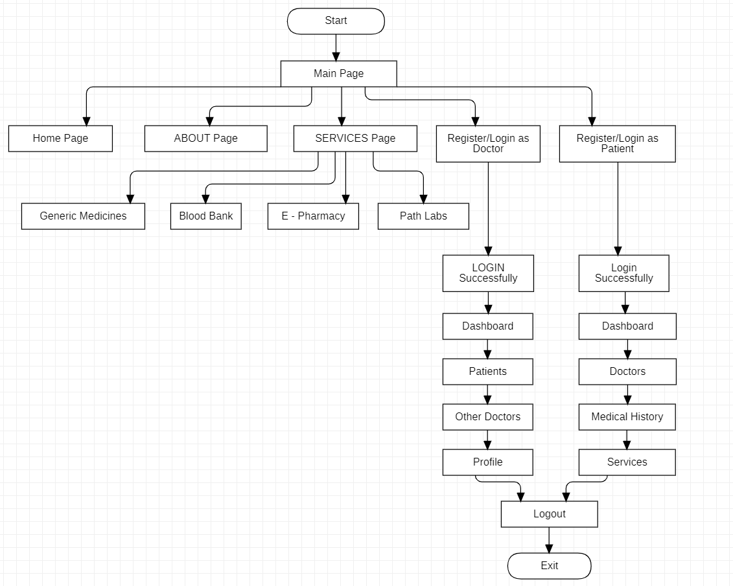
Fig 3.1: Flowchart

3.2 SYSTEM DESIGN USING DFD LEVEL 0 AND LEVEL 1
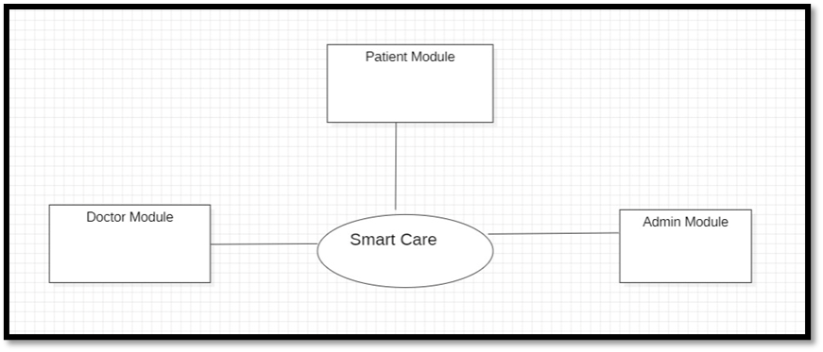
Fig 3.2: DFD Level 0

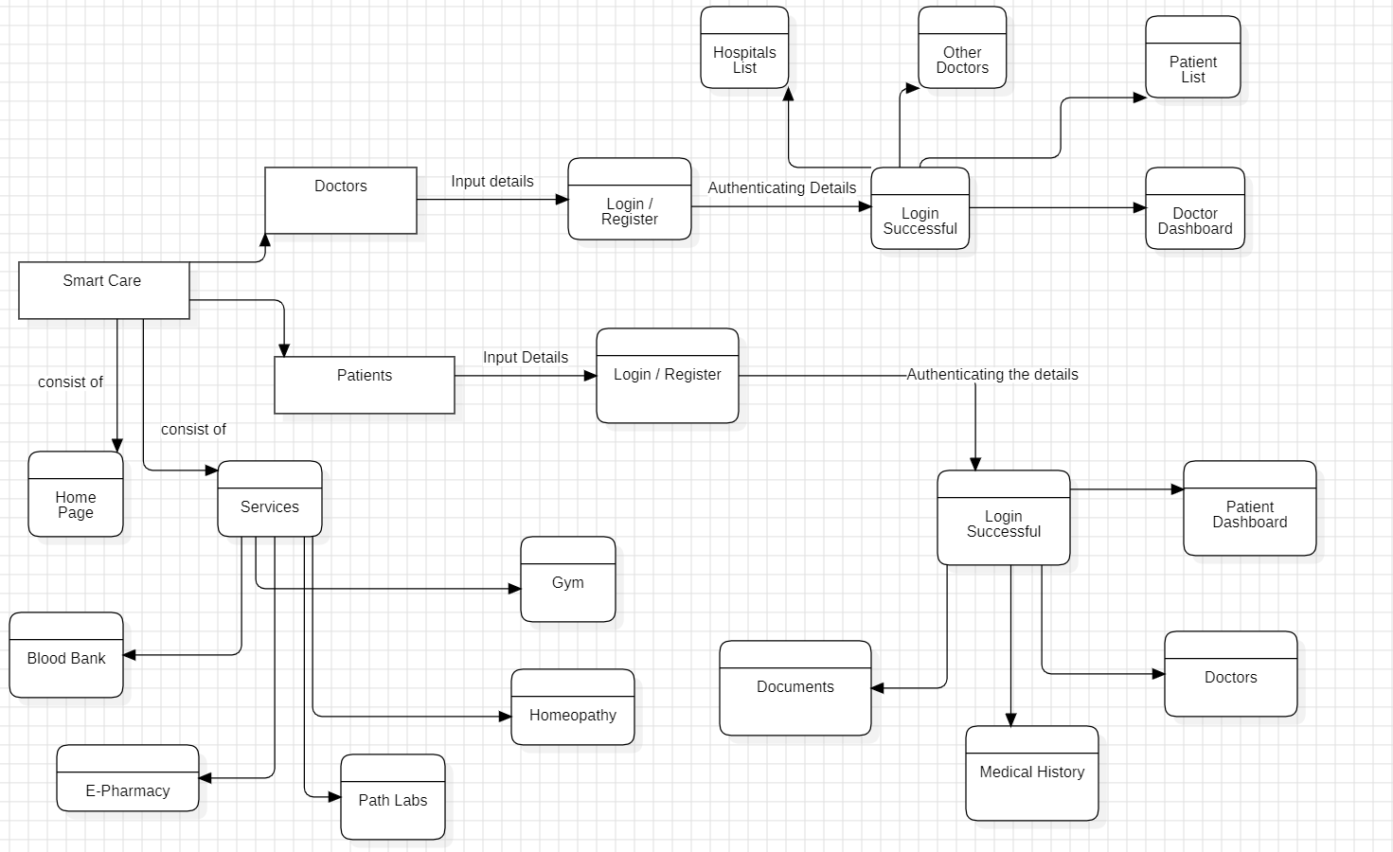
Figure 3.3: DFD Level 1

3.3 USE CASE DIAGRAM

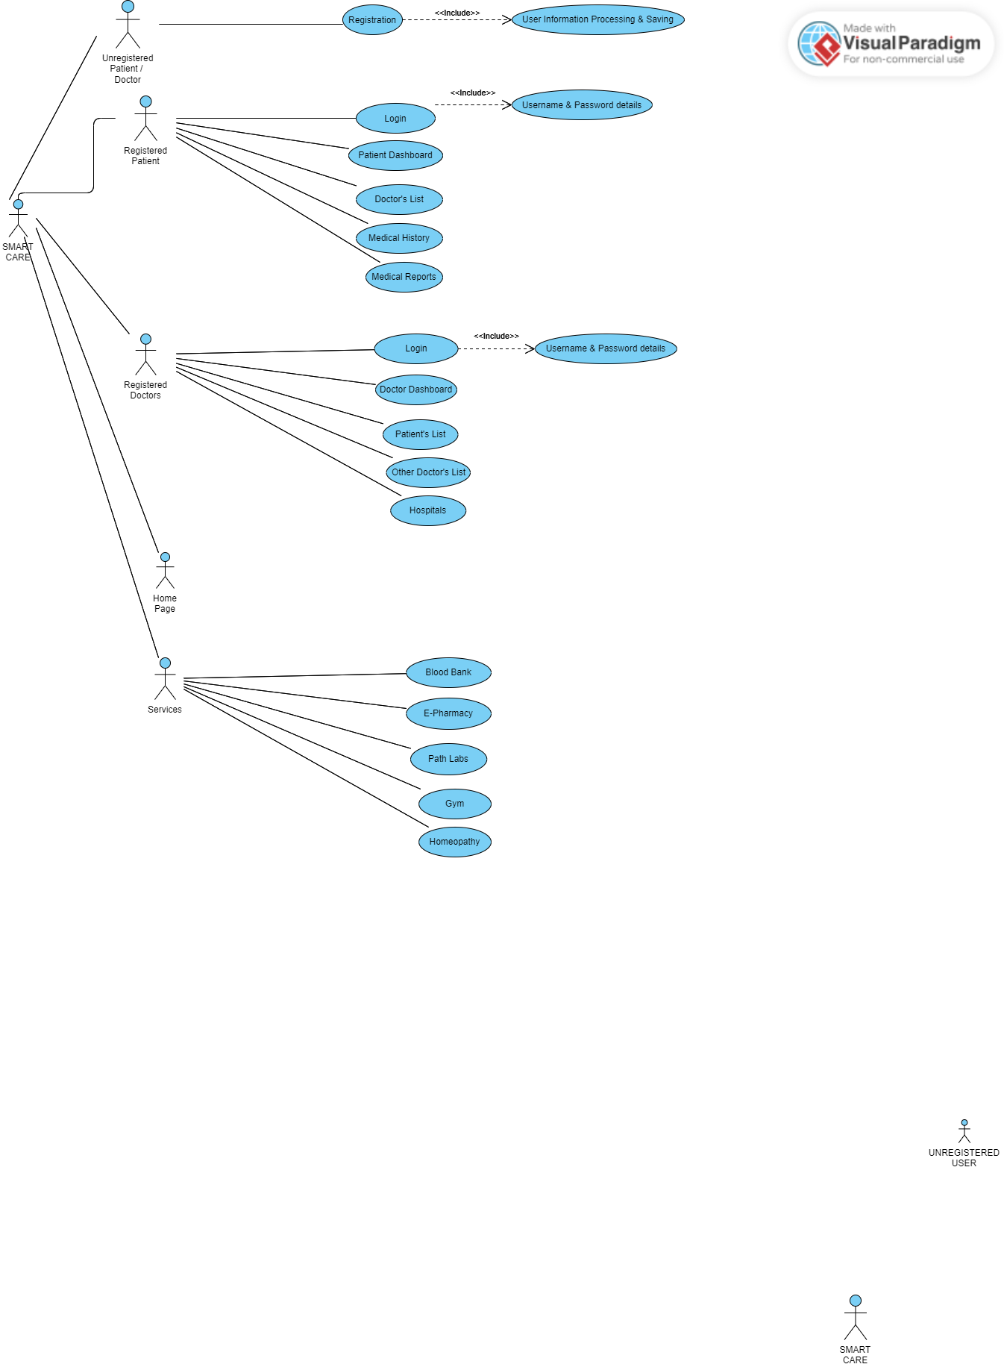
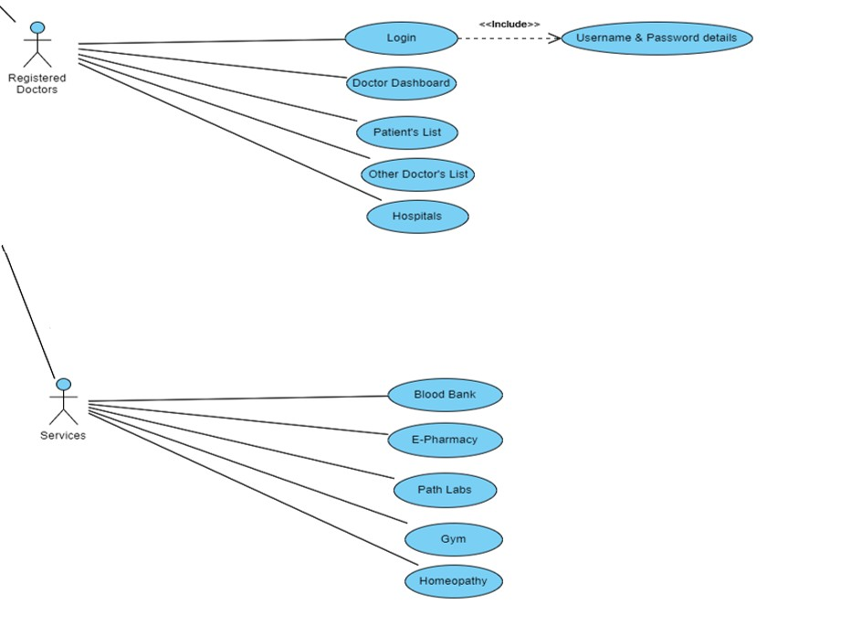
Figure 3.4: Use Case Diagram of Smart Care

3.4 DATABASE DESIGN
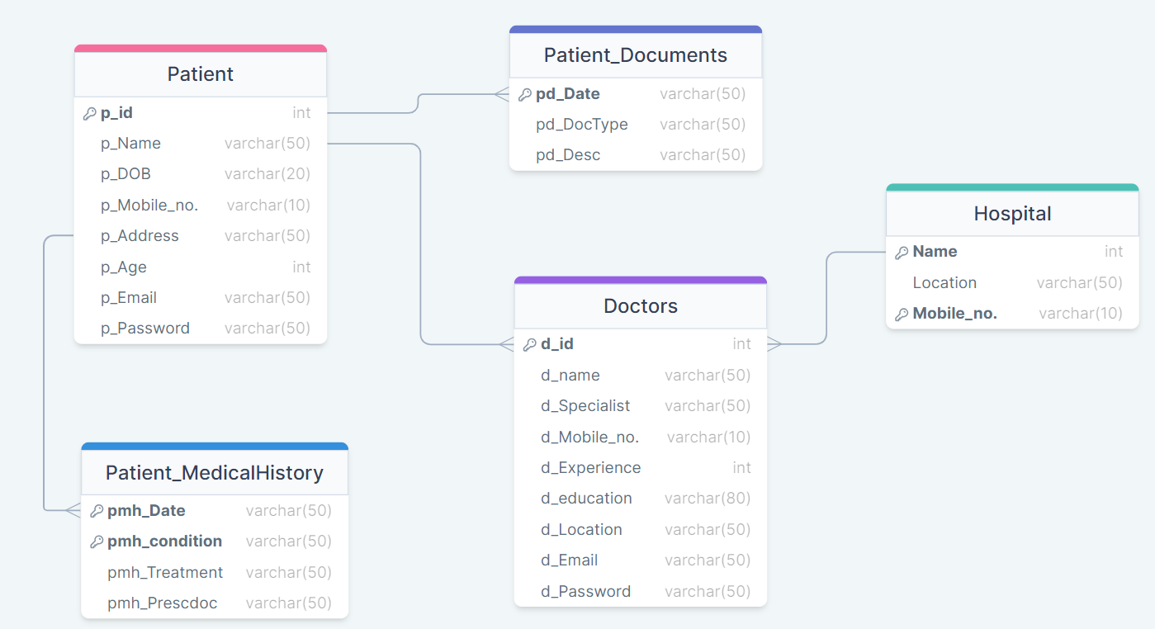
Figure 3.4: Database Diagram of Smart Care

3.4.1 ER DIAGRAMS
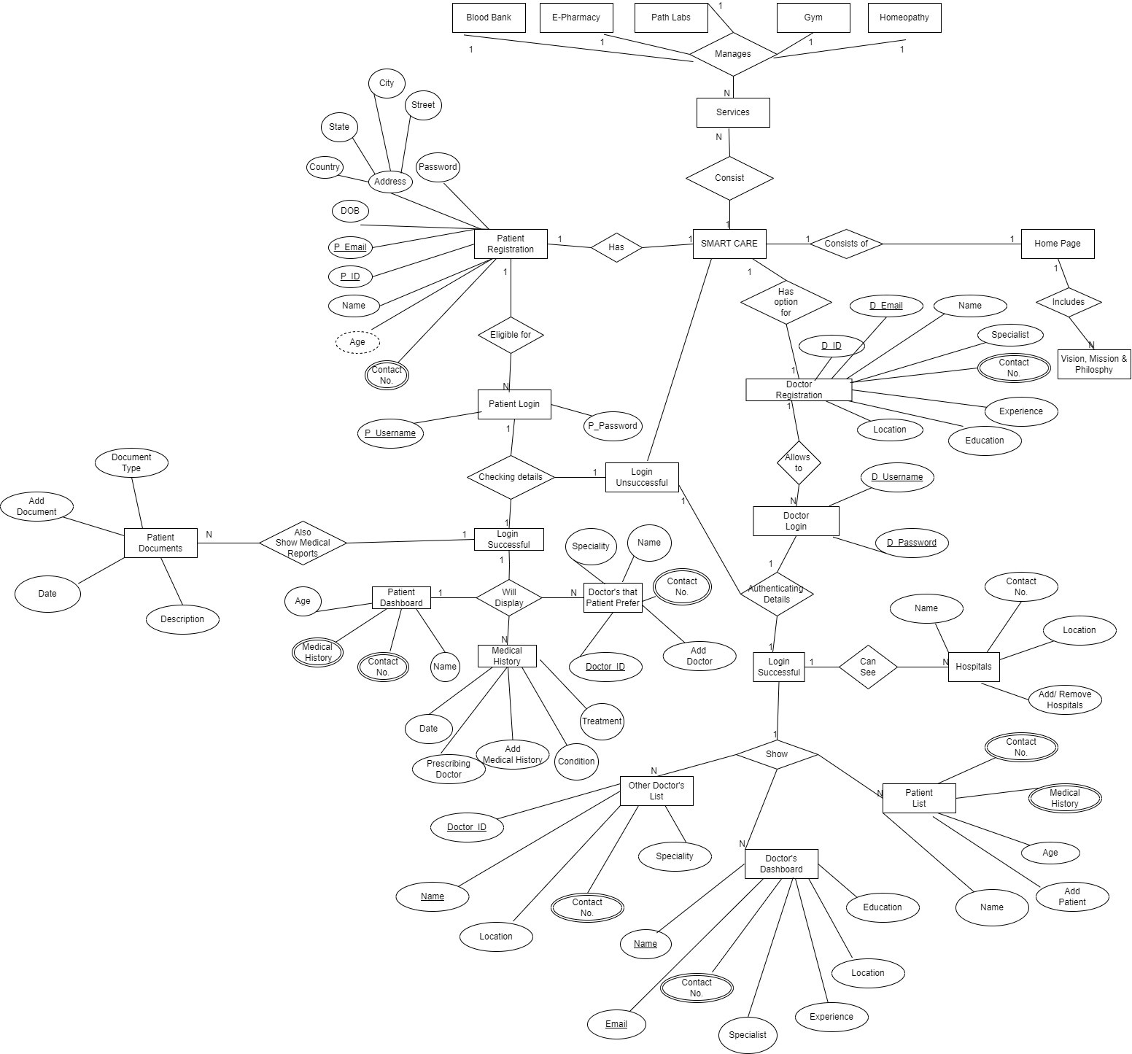
Fig 3.5 : ER Diagram of Smart Care

CHAPTER - 4
IMPLEMENTATION, TESTING, AND MAINTENANCE

4.1 INTRODUCTION LANGUAGES, TOOLS AND TECHNOLOGIES USED FOR IMPLEMENTATION

- Hardware –
Even though this architecture is hardware- software integrated web architecture, we will not be designing any specific hardware interfaces to run the system. Our system is a web-based system, so we will be launching it in several computers online. Smart care projects may integrate with EHR systems to provide healthcare professionals with access to patient data. These systems can be connected to the web-based platform via APIs.

- Software –
The Smart Care WebApp will depend on several open-source software components, including Html, CSS, JavaScript, API’s ,Spring MVC, Spring Security, Spring JDBC and Spring Boot. These components will be integrated into the web application to provide the necessary functionality and user interface. It is important to note that the operating environment described above is subject to change based on the needs of the project and the evolving requirements of the web application. It is recommended that the development team regularly review and update the operating environment to ensure that the software remains compatible with the latest technologies and platforms.

4.2 TESTING TECHNIQUES AND TEST CASES USED
We aim to test our project at the following levels :
Unit Testing: This is the lowest level of testing and focuses on individual components or functions within the software. Developers often perform unit tests to verify that specific parts of the code work correctly.
Integration Testing: This level of testing checks how different components or modules of the software work together. It ensures that integrated parts of the software function as intended.
System Testing: At this level, the entire system is tested as a whole. It verifies that the software meets its specified requirements and functions properly in its intended environment.
Test Cases
- Unit Testing
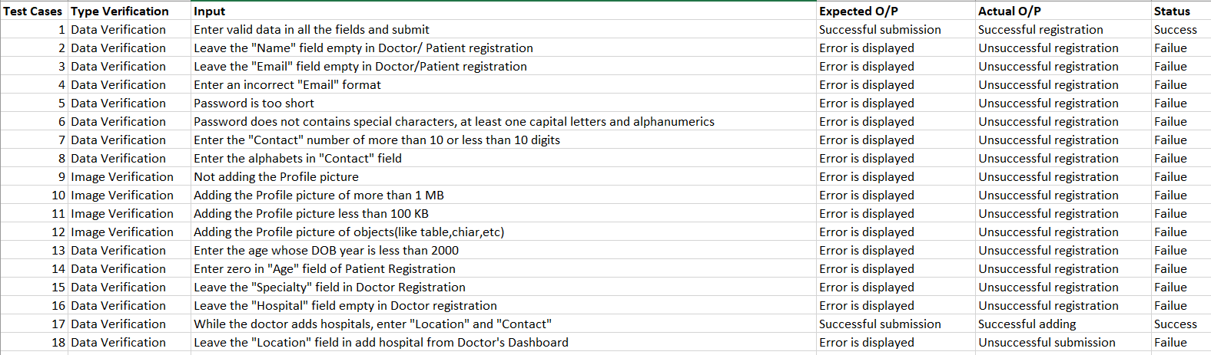
- Equivalence Testing
Image uploaded in Patient / Doctor Registration

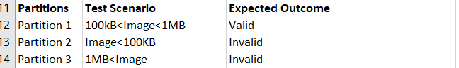

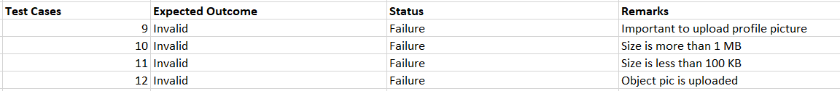
DOB in Patient Registration
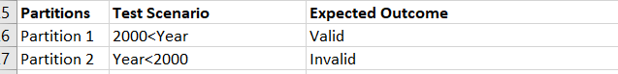

- Decision Table

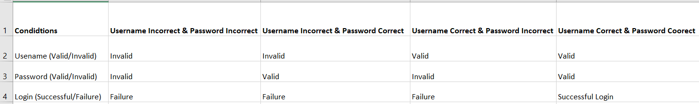

- Boundary Value Analysis

Image uploading
100 KB < Image < 1 Mb

Min = 100 KB
Min + 1 = 101 KB
Max = 1 Mb
Max – 1 = 1023 KB
Nominal = 500 KB

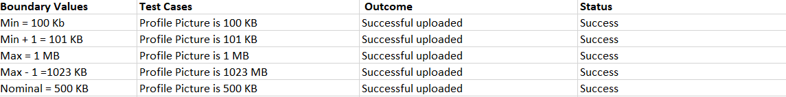

Year in DOB
2000 < Year

Min = 2000
Min + 1 = 2001
Max = 2050
Max – 1 =2049
Nominal = 2025

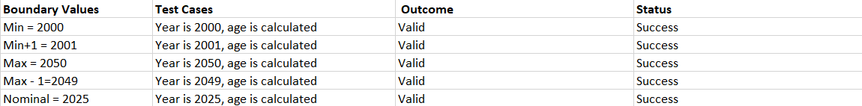

CHAPTER - 5
RESULTS AND DISCUSSIONS

5.1 USER INTERFACE REPRESENTATION (OF RESPECTIVE PROJECT)
The major interfaces of the website are:
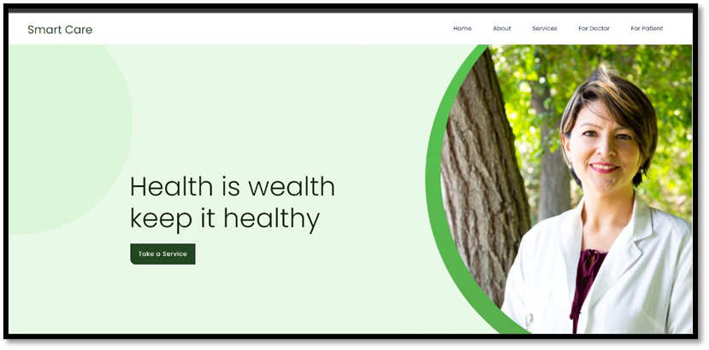
Figure 4.1: Showing the Home Page
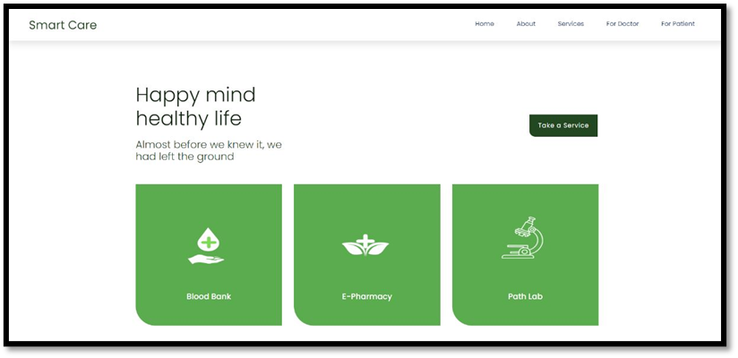
Figure 4.2: Showing the Services section
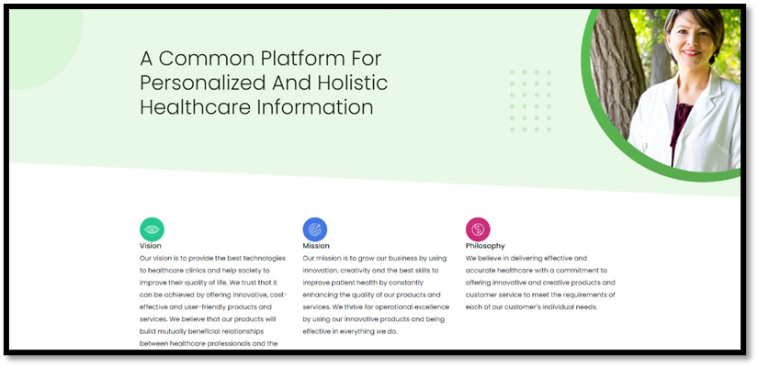
Figure 4.3: Showing the About section
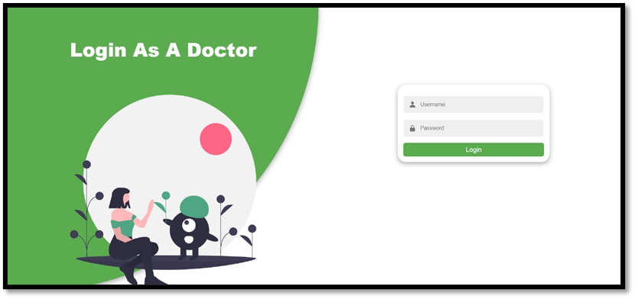
Figure 4.4: Showing the Login Page for Doctor
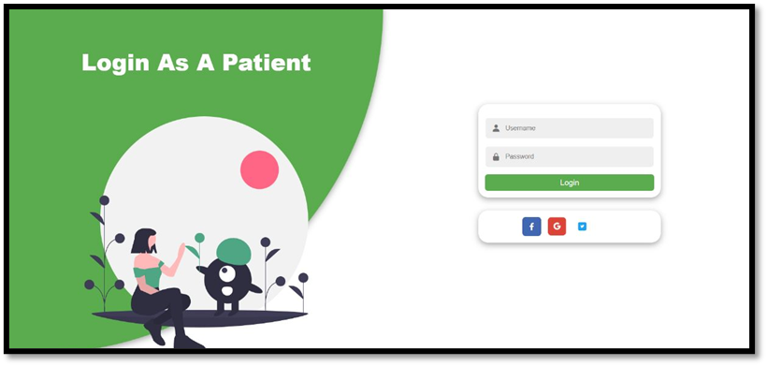
Figure 4.5: Showing the Login Page for Patient
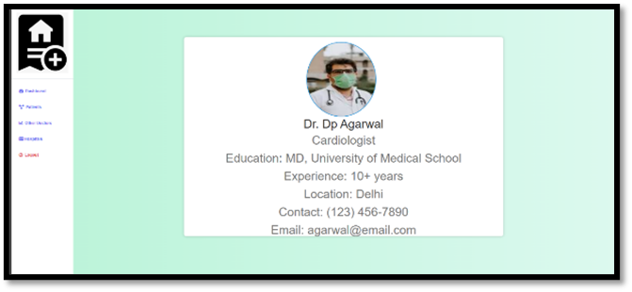
Fig. 4.6. Doctor Profile at interface

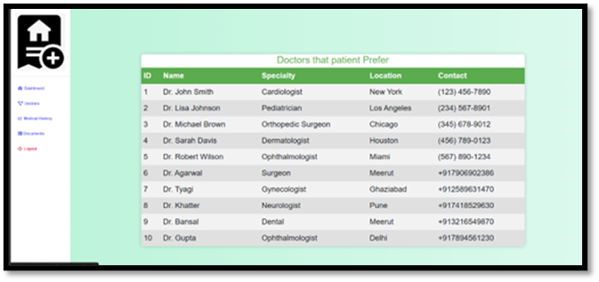
Fig. 4.7. Interface layout for the list of doctors

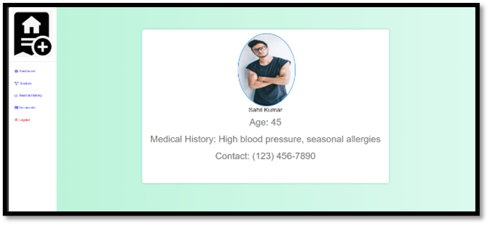
Fig. 4.8. Patient’s data on the interface

5.1.1 BRIEF DESCRIPTION OF VARIOUS MODULES OF THE SYSTEM
The two main modules of the system are patient and doctor.
Doctor module. This is the main module including many features:-
• Profile page include doctor experience and history of previous hospitals and many more.
• Patient record includes all the patients of doctor with medical history all reports , medicines and diseases .
• Doctors includes other doctors that are registered and every doctor can see other doctor profile for their patients and for their knowledge.
Patient module. The module includes:-
• Profile page include patients profile of previous doctor visits and medical reports .
• All doctors where visit for chech up and prescription given by doctor.
• Patient can view all their past documents in digital format.

Another module is the interface where Service Page is provided for ease of use.
• This is most important modules including many government services and generic services.
• Blood Bank is very necessary now days and this module include access links of government blood bank websites and listing necessary details regarding them.
• E pharmacy is pharmacy where we can buy medicines online and delivered at our doorstep at lowest price and with assured company.
• Path Labs is nearest path labs your location with price tags of many important medicals test and report at your doorstep.

CHAPTER - 6
CONCLUSION AND FUTURE SCOPE
CONCLUSION
The Smart Healthcare website which aims to solve many problem of patients and doctors that it provides the facility of saving the medical reports online. Sometimes when patients changes their doctors, then some of patients lost their prescriptions and are unable to tell doctors about their previous health issues so they can save all of their reports and documents on the platform for their better cure and this help a lot to patients as well as doctors. The platform is also helpful for doctor as they can save all their patients history in efficient manner. Doctors can also refer prescriptions of other doctor for betterment, both patients and doctor can also compare price of medicine so that they can save their money.

Future Scope
- Integration of Advanced Technologies:
- AI and Machine Learning: Implementing advanced AI algorithms for predictive analytics, personalized treatment plans, and early disease detection.
- IoT (Internet of Things): Integrating wearable devices and sensors for real-time monitoring of patient vitals and health parameters.
- Virtual Reality (VR) and Augmented Reality (AR):
- Using VR for immersive therapy sessions and pain management.
- AR applications for doctors, providing augmented information during consultations and procedures.
- AI-driven Decision Support Systems:
- Developing intelligent decision support systems to aid doctors in diagnosis and treatment planning.
- Streamlining administrative tasks through automation, allowing healthcare professionals to focus more on patient care.

Refrences
- mailto:http://groups.umd.umich.edu/cis/course.des/cis375/active/class7/EM-SRS-ReviewSoftRightHospitalManagementSystemSRS.pdf
- mailto:1. Simon de Lusignan , Freda Mold, Aziz sheikh…(2013)Patients’ online access to their electronic health records and linked online services: a systematic interpretative review.
- mailto:2. Mandl KD, Szolovits P, Kohane IS-Public standards and patients’ control:
- mailto:Hassol A, Walker JM, Kidder D, -Patient experiences and attitudes about access to a patient electronic health care record and linked web messaging. J Am Med Inform Assoc (2004)

REFERENCES

[1] isi.edu/nsnam/ns/tutorial Marc Greis tutorial on ns2 on, 12 October 2013.

[2] Matthias Transier “Ns2 tutorial running simulations”.

[3] D. Kim, J. Garcia and K. Obraczka, “Routing Mechanisms for Mobile Ad Hoc Networks based on the Energy Drain Rate”, IEEE Transactions on Mobile Computing. Vol 2, no 2, 2003, pp.161-173.

[4] C.E. Perkins & P. Bhagwat, “Highly Dynamic Destination Sequence-Vector Routing (DSDV) for Mobile Computers”, Computer Communication Review, vol. 24, no.4, 1994, pp. 234-244.

[5] C.E. Perkins and E.M. Royer, “Ad-Hoc on-Demand Distance Vector Routing,” Proc. Workshop Mobile Computing Systems and Applications (WMCSA ’99), Feb. 1999 pp. 90-100.

[6] David B. Johnson and David A. Maltz. “Dynamic source routing in ad hoc wireless networks”, Mobile Computing, Kluwer Academic Publishers. 1996 pp.153–181, 1996.

[7] M. S. Corson, J. P. Maker and G. H. Cirincione , "Internet-Based Mobile Ad Hoc Networking," IEEE Internet Computing, Vol. 3, no. 4, July-August 1999, pp. 63-70.

[8] V. Ramesh, Dr. P. Subbaiah, N. Koteswar Rao and M. Janardhana Raju,"Performance comparison and analysis of DSDV and AODV for MANET," (JJCSE) International Journal on Computer Science and Engineering , vol. 02 , pp. 183-188, 2010 Md. Monzur Morshed; Franz I. S. Ko; Dongwook Lim; Md. Habibur Rahman; Md. Rezaur Rahman Mazumder; Jyotirmoy Ghosh.

